Steps to get data

1. Go to takeout.google.com

2. Sign in using your main gmail account

3. First, click the deselect all button at the top of Step 1

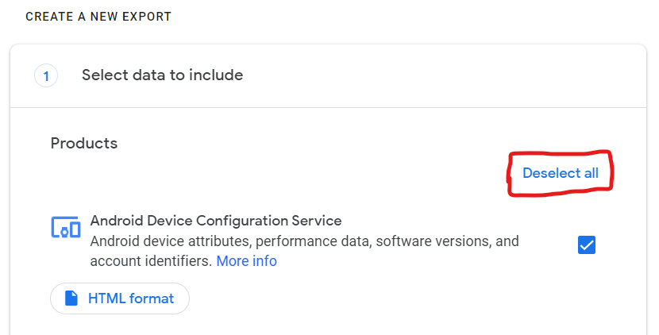

4. Check the box next to Chrome

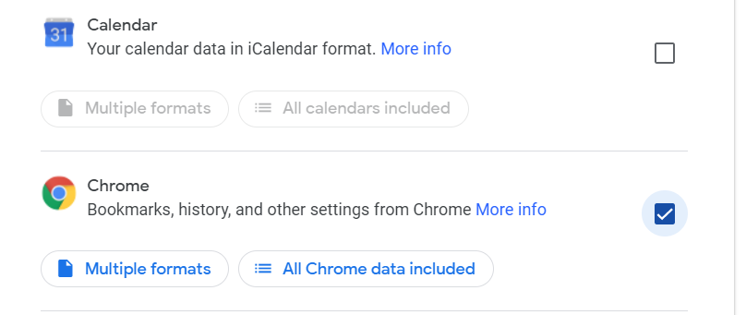5. Check the box next to YouTube and then go to Next Step

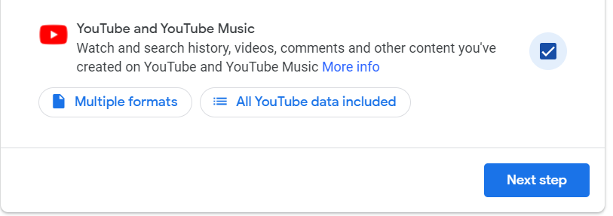

6. Select Export Once and then Create export

8. Wait for a little bit, it should only take a minute or two and at the top of the page, click manage exports

9. Download the top export and give us this zip file that you downloaded